Introduction

Youtube Link: <https://youtu.be/sBfssNRUTNg>

# ScreenShots:

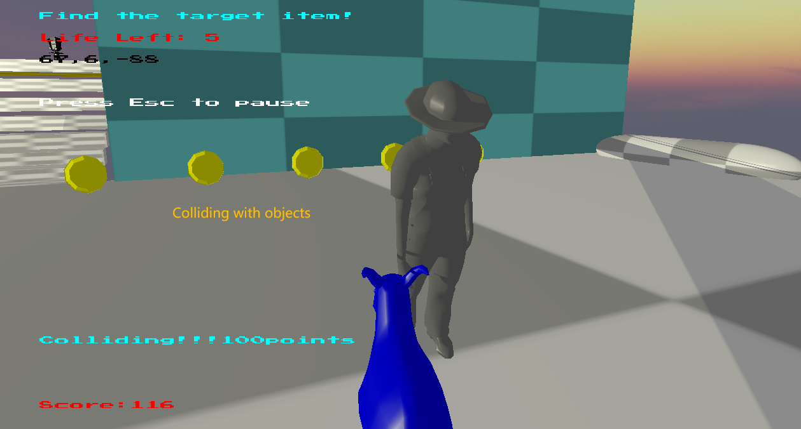

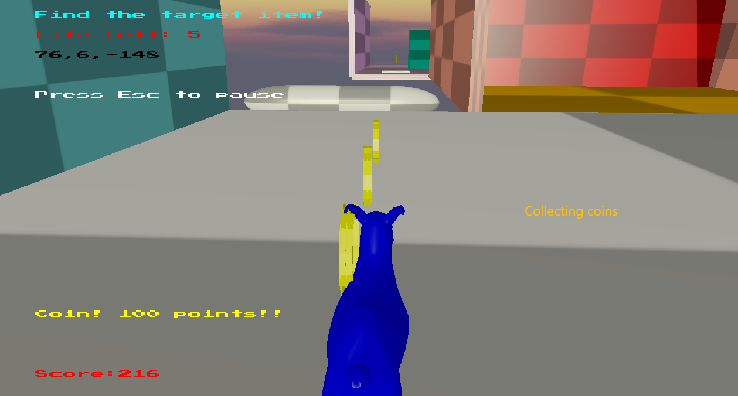

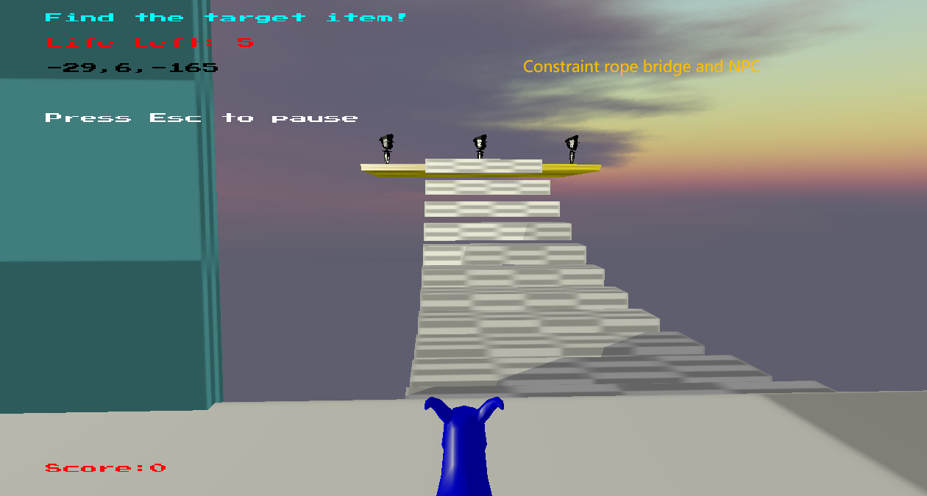

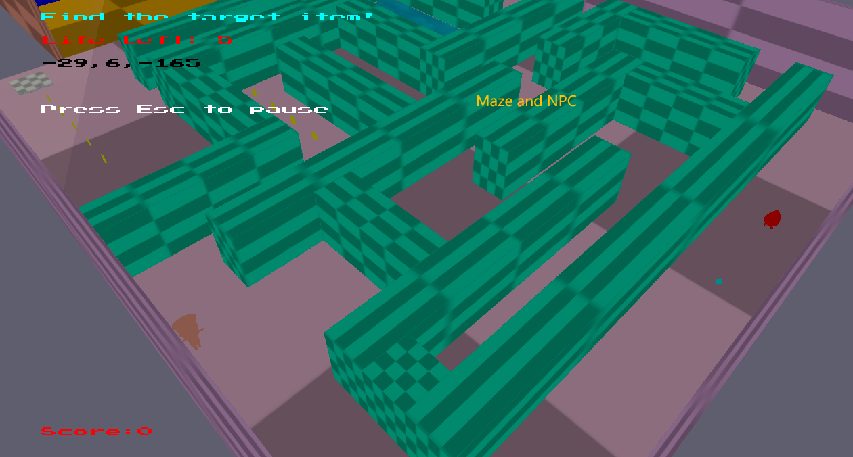

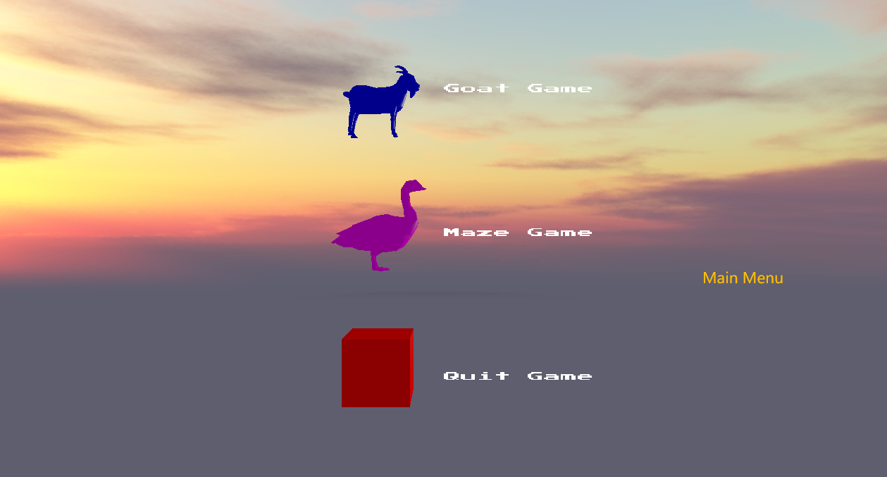

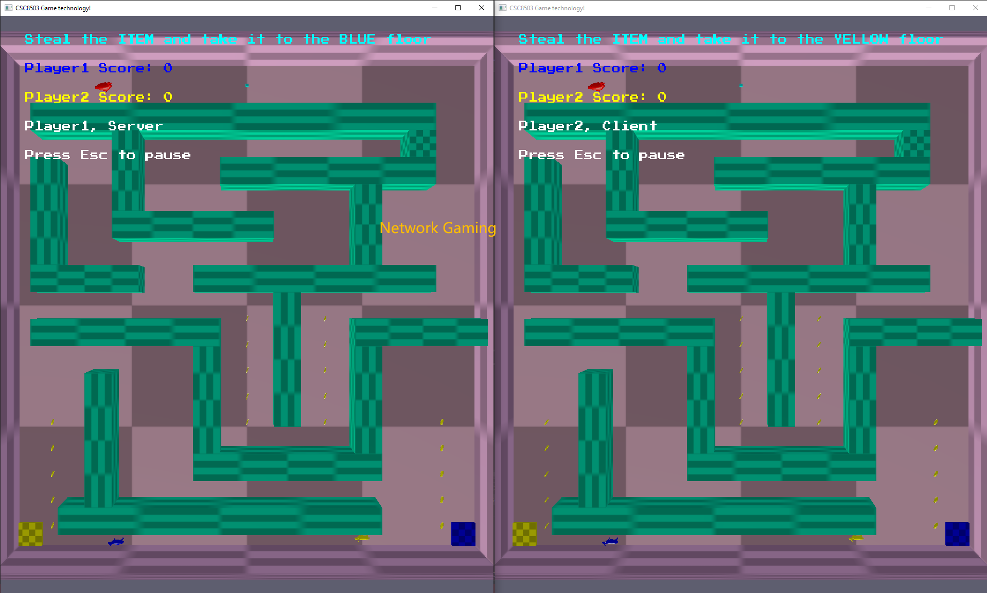

# Features

1. Using AABB, OBB and sphere collision volumes
2. Using projection, impulsive and penalty resolve collision
3. Player can gain score via various ways
4. Move the player goat by applying force
5. Different view points
6. Octree to speed up the collision detection
7. Points calculated by the collision penetration
8. Using position constraints and orientation constraints
9. Seven different powerups(3 hidden)
10. Using raycasting to perform shooting and hook
11. Points calculated by the local raycasting collision point
12. Two keys for two gates
13. Coins to be collect
14. Target item to be collect
15. Application of elasticity and friction
16. NPCs based on state machine and behaviour tree
17. NPCs attack player based on pathfinding and raycasting
18. NPCs interact with player by dialog
19. Triggers used to gain extra points
20. Airwall to clear or reset objects
21. Menu system
22. Network gaming, player’s position, orientation, colour, score, item information and finish information will be transmitted in the packets

# Key List

KeyBoard:

1: First view point

2:Second view point

3:Third(top) view point

WASD: Control the movement of the goat in the first view point, or the movement of camera in the second view point

Space: Jump or fly in the first view point, or the movement of camera in the second view point

Shift: Drop height when flying in the first view point, or the movement of camera in the second view point

Left,Right,Up,Down: Control the movement of the goat in the second or third view point

R:Discard a powerup

T:Discard a key

G:Swap gravity direction in gravity powerup mode

Mouse:

Right: Enter raycasting mode in shoot or hook powerup

Left: Shoot or hook